GSA Website Directions
Updated 10/08/2018
The cost of meals shall be reimbursed based upon the applicable per diem rate for meals expenses as shown on the
US General Services Administration web site (www.gsa.gov/mie), based on the per diem rates for the travel destination.

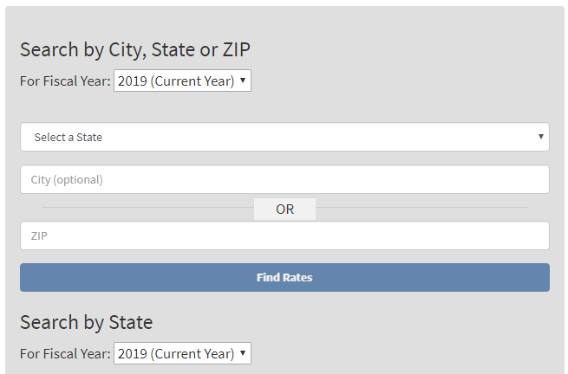
Enter page into web browser:
https://www.gsa.gov/travel/plan-book/per-diem-rates

From this website page, search for travel destination by city, state, or zip code.

Be sure to indicate FY2019 for travel after 10/1/2018.

Then select Find Per Diem Rates.

Example of web page you will be directed to after selecting Find Per Diem Rates.
No reimbursement shall be allowed for any meal which is provided or made available to an employee as part of the cost of a meeting, class, or other function, regardless of whether the employee partakes of the provided meal or purchases his/her meal elsewhere.

Lodging rates by month/location:
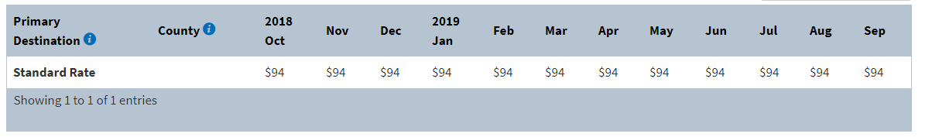
Meal Rates:
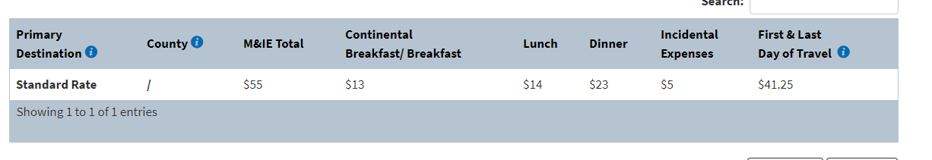
Chart shows allowable nightly Room Rate and daily Meal Reimbursement Rate by meal period.
Travel is for official County business only. Meals will be reimbursed if the employee is required to leave his/her normal work location between these hours:

Breakfast: before 6am, returning after 10am.

Lunch: before 10am, returning after 3pm.

Dinner: before 4pm, returning after 8pm.

Nye County is considered a standard Continental United States (CONUS) location which is an allowance of $55.00 per day; however; Nye County does not allow reimbursement of the $5 incidental expense rate.

Nye County Rate (as of 10/01/18):
$13.00 – Breakfast
$14.00 – Lunch
$23.00 – Dinner

