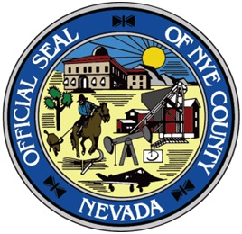
Grant Project Number Request
Project Number:
Department: | Date:
Project Manager: |  | Phone #:
Grant Title:
Grant #: | CFDA #:
Grantor:
Grant Period From: To:
Reporting Requirements (monthly, quarterly, annually) | Financial: | Progress: | Other:
Date BoCC Approved to Apply: Date BoCC Approved to Accept:
The following documentation must be included with request form prior to project # being issued:
- Copy of all BOCC action and back-up provided.
- Copy of approved Grant Award Documents and back-up documentation, to include: approved budget; terms and conditions; and special conditions, if applicable.
- Copy of Authorization to Proceed or correspondence allowing project to proceed.
Miscellaneous Information:

Budget Information: Total of grant funds, plus matching funds, if applicable, should equal total expenditure budget. If grant is a multi-year grant please include budget amount for each period of grant.

Include Project Phase and any subsequent Tasks and Sub-Tasks per Phase (if applicable). Typical Grant Categories: Personnel/Fringe; Travel; Equipment; Supplies; Contractual; Construction; Other

Example – Grant $75,000 & County Match of $5,000 = Project Total $80,000:
Right Click & select Update Field
Total Grant Funds: $ |  | Total Matching Funds: $ |  | Total Project: $ 0.00
Phase Description | Task Description | Sub-Task Description | Expenditure Account | Budget |  | Expenditure String
USDA Grant | Contractual |  | 10340-10-10-02-5369 | $60,000.00
 | Salary/Benefits |  | 10340-10-10-02-5110 | $15,000.00
County Match | Supplies | Postage | 10101-10-10-02-5322 | $250.00
 |  | Office (paper, etc.) | 10101-10-10-02-5312 | $4,750.00
 |  |  |  |  | Finance Use Only
Attach additional sheets if necessary.
Grants Revenue: 10340-10-4380

